DML Commands – INSERT, SELECT, DELETE AND UPDATE
EX NO:2

AIM
To perform Data Manipulation Language (DML) operations such as INSERT, UPDATE, DELETE and SELECT on the MobileSales table.
PROCEDURE
- Select the required database using the USE command.
- Display the existing records in the MobileSales table.
- Insert a new record into the table using the INSERT statement.
- Display the table to verify the inserted record.
- Modify the price of a mobile using the UPDATE statement.
- Display the table to verify the updated record.
- Delete a record from the table using the DELETE statement.
- Display the table to verify that the record has been deleted.
- Execute a SELECT statement to retrieve all records from the table.
- Observe the output and verify that all DML operations have been executed successfully.

1. Select the Database
USE MobileDB;

2. Display Existing Records
SELECT * FROM MobileSales;

3. Insert a New Record
INSERT INTO MobileSales
VALUES ('Realme15',32000,4.3,3500,2026,256);

4. Display Records
SELECT * FROM MobileSales;

5. Update the Price of MotoG36
UPDATE MobileSales
SET Price = 22000
WHERE MobileName = 'MotoG36';

6. Display Records
SELECT * FROM MobileSales;

7. Delete the Record of Realme15
DELETE FROM MobileSales
WHERE MobileName = 'Realme15';

8. Display Final Records
SELECT * FROM MobileSales;

OUTPUTS

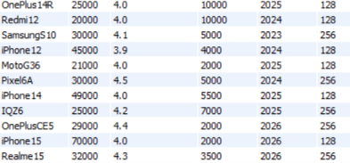

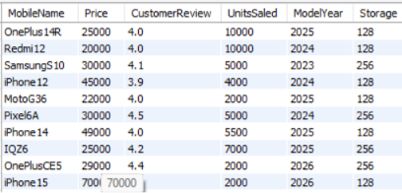

RESULT
Thus, the DML commands such as INSERT, UPDATE, DELETE, and SELECT were successfully executed on the MobileSales table, and the records were inserted, modified, deleted, and displayed successfully.

